Публикувана на 22.06.2017

LEM – “At the Heart of Power Electronics”

LEM is the market leader in providing innovative and high quality solutions for measuring electrical parameters. Its core products - current and voltage transducers - are used in a broad range of applications in drives & welding, renewable energies & power supplies, traction, high precision, conventional and green cars businesses. LEM’s strategy is to exploit the intrinsic strengths of its core business, and to develop opportunities in existing and new markets with new applications. LEM is a mid-size, global company. It has production plants in Beijing (China), Geneva (Switzerland), Machida (Japan) and Sofia (Bulgaria). With its regional sales offices close to its clients’ locations, the company offers a seamless service around the globe. LEM is listed on the SIX Swiss Exchange since 1986; the company’s ticker symbol is LEHN.

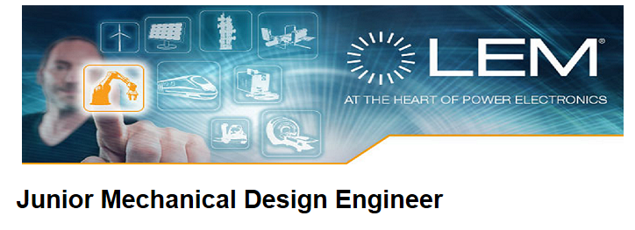

Main tasks:

- Support with mechanical design with accordance to the customer specifications and regulations (ISO standards, CE marking, UL marking, Reach and ROHS);

- Create and launch drawing documentation (2D drawings, marking, assembly, outline drawings, etc.);

- Prepare initial samples dimensional reports;

- Provide technical support to other departments in accordance with his/her field of expertise (mechanics);

- Contribute to the achievement of the target cost and development schedule;

- Run the necessary calculations and simulations with detailed reporting;

Professional background:

- Engineering University degree in Mechanics, Mechatronics;

- Knowledge of CAD system a must;

- Fluent in spoken and written English, using French is a key asset;

Key personal skills:

- Creative and knowledgeable about mechanical design practices in an industrial environment;

- Compliant with company procedures;

- Motivated to research and develop new interesting solutions;

- Open to work in an international environment and culture;

- Ability to work in team;

What we offer:

- Opportunity to be part of a dynamic, successful and continuously growing international company;

- Flexible working time;

- A friendly and open working environment;

За контакти: Никол Георгиева

e-mail: NGe@lem.com

